Social Media - Web Scraping Using Python

Assignment submitted to

Graduate School at

The University of Arkansas at Little Rock

in partial fulfillment of

requirements for the graduate course of

202510 Spring: Data Science - Technologies (9U1)

in

March 2025

by

Deepak Singla

Instructors

Dr. Elizabeth Pierce

and

Dr. Serhan Dagtas

Assignment Instructions

For this assignment, check out this Python Web Scraping Tutorial - <https://www.geeksforgeeks.org/python-web-scraping-tutorial/>. Try implementing one of the techniques and submit your output (along with a brief description of the technique you used to do some simple web scraping). Submit your work to the Assignment Folder.

ABSTRACT

For the purpose of the assignment, I have chosen <https://cognitiveclass.ai/courses> page.

Following tools and libraries have been used to demonstrate the process of webscrapping from a public page.

* <https://colab.research.google.com/> as the platform to run the code
* Python
* Request Module from Python
* BeautifulSoup Module from Python

Steps followed

* Send a request using URL
* Parse the response from the requested URL
* Find the content web scrapping is done from parsed data by searching html document on tags.

Code Snippet

Following code snippet has been used to extract titles from the requested URL.

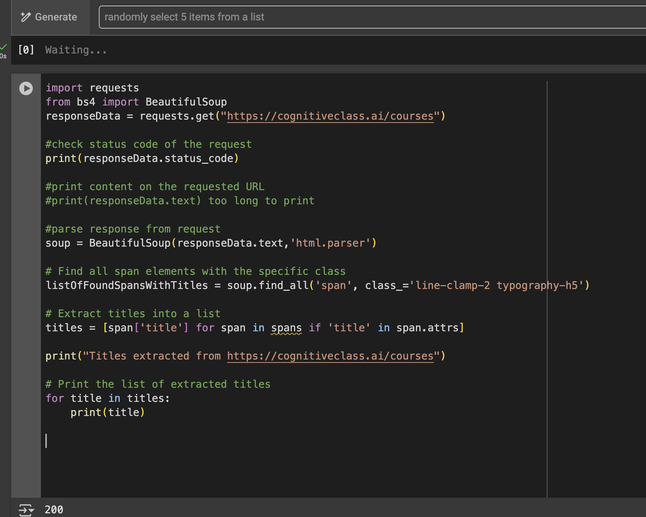

Using *requests* module, a get request is sent to the requested URL and response in save in a variable *responseData.*

Using *BeautifulSoup* library html in *responseData* is parsed. Then the parsed is searched using method *find_all* on html tags and class name.

Output

Following is the final output of the code above.

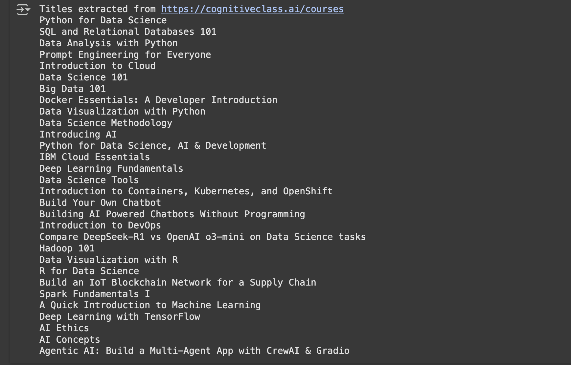

Credits

Report format has been copied from

<https://www.proquest.com/pqdtlocal1009983/docview/2902800999/fulltextPDF/C967C462E7DF4DF2PQ/1?%20Theses&accountid=14482&sourcetype=Dissertations%20>

Other References

<https://cognitiveclass.ai/courses>

<https://www.geeksforgeeks.org/python-web-scraping-tutorial/#requests-module>